A1 Individual
Word counts: 1303
Section 1: Human-Centered Project Ideas
Idea 1: Smart Training Assistant for Badminton Players
User group: Amateur badminton players
Problem space: Non-professional badminton players or enthusiasts usually lack knowledge of personalized coaching. They often start playing when they want without and scientific plans. This results in hindering their ability to improve skills efficiently and being injured.
Significance: This project will provide a kind of app, which can be downloaded into own phones to access high-quality training. Users can customize their drills, see their performance analytics with virtual coaching feedback, as well as avoid unnecessary hurts.
Access to user group: I have friends who play badminton, and I will easily contact them virtually or in person.
Personal connection: Actually, I am a badminton player. I will put my passions and personal experiences aligned with this project. I know less people want to waste plenty of time for searching professional training before hand-on playing. Begin as easy as possible!
Idea 2: Stress Management App for Student Athletes
User group: Student Athletes at universities
Problem space: Playing dual roles of both sports and academics is stressful! High levels of pressure will negatively impact their mental and physical health, sometimes will affect their overall performance in life.
Significance: This app will provide tailored health resources, including stress tester, time management strategies of training and mindfulness exercises, helping reduce burnout.
Access to user group: This link: https://cornellbigred.com/staff-directory shows all coaches and staff at Cornell for Student Athletes. We can contact them to collect the overall information!
Personal connection: Managing dual demands of sports and academic development is difficult. Work-Life balance is dramatically lost, and I want to help with my hands as a causal sports players.
Idea 3: Off-Campus Housing Search for International Students
User group: International students who are seeking off-campus accommodation.
Problem space: Challenges such as cultural barriers, unfamiliarity with the rental processes, and unknown housing resources are obstacles for international students who want to live off-campus.
Significance: This project aims to simplify the housing search with a platform, helping international students, or those who come from other states at Cornell find suitable accommodation quickly with less fakers.
Access to user group: Students who live in apartments around the university are all targets. Lux and Lofts, CTT, Collegetown Center, and so on. I have many friends who are living in these apartments, and easily to interview them how they find a rental place.
Personal connection: I will say that I this project resonates when I have experienced searching and moving to the US for school, and I have a desire to help others navigate transitions with my experiences.
Idea 4: Nutrition Tracker for Diet
User group: Casual fitness enthusiasts who wants to improve their health and performance at home.
Problem space: A lack of personalized nutrition guidance can lead to inconsistent fitness results, thinking about diet failure.
Significance: A nutrition tracker that offers customized meal plans, nutritional advice, and progress tracking can help users optimize their diet and improve their health. Also, most important, it will be totally free! Without hiring any advisors or buying books
Access to user group: Go local gyms, like our apartment exercise room, and go to Helen Newman Hall, randomly catch someone for interviewing!
Personal connection: I have friends who are majoring in nutritional science, so we will get some professional suggestions, and I really want to improve my daily diet for heath.
Idea 5: Anime and Gaming Social Platform for Cross-University/College Students
User group: Different university/College students passionate about anime and gaming.
Problem space: Students often find it challenging to connect with like-minded peers across different campuses, limiting opportunities for social interaction and multi-community engagement.
Significance: This platform will create a cross-campus community, not on some specific apps like Instagram, but can be connect with those sorts of app accounts. Easily connect with existing groups as well as expend social connections. This will allow students to engage in shared interests in anime and gaming to enhance mental well-being as well as strengthen connections between different universities with activities besides sports normally.
Access to user group: Leverage social media groups and online forums. Friends who are in anime and gaming club at other universities or colleges.
Personal connection: I like watching anime and playing games, so I prefer to foster a sense of community among fellow fans!

Section 2: Usability & UX Analysis
Idea 1: Smart Training Assistant for Badminton Players
A mobile app that offers drill instructions, performance analytics, and customized feedback based on user data. Amateur badminton players can use this app to receive coaching tips, track training metrics, and improve techniques. Since it will exist in phone, players can open it everywhere they want, such as in a gym, on a badminton court, or at home. Even when sitting or lying in bed can also interact it by adjusting plans, watching recording gameplay, receiving feedback. Indeed, there are such apps like fitivity and prefeo (shown in following pictures).
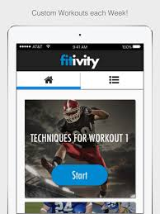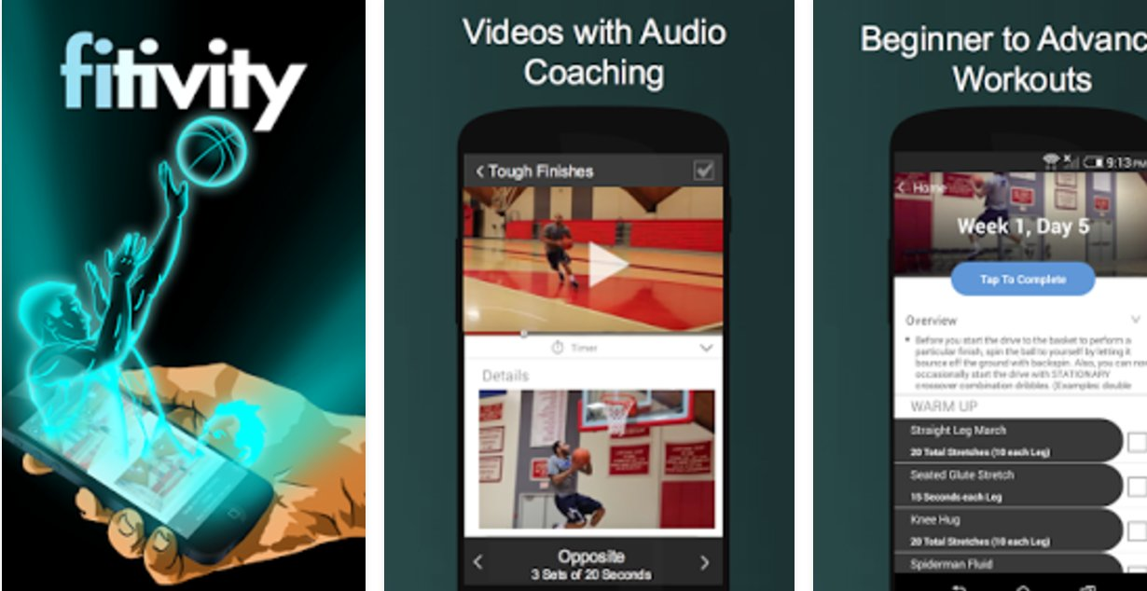
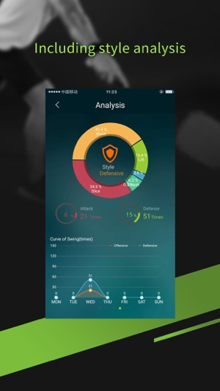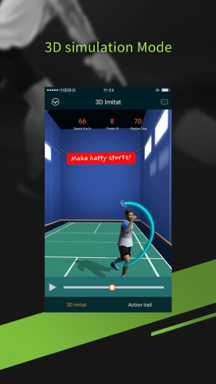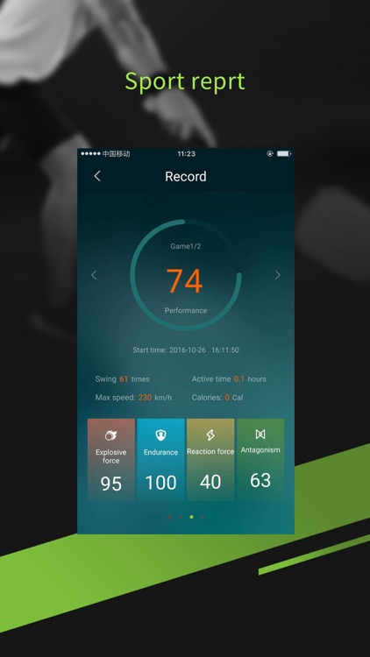
Usability analysis:
- Visibility: The app uses visibile icons and color-coded progress bars to indicate user performance. Feedback will be immediate, with visual cues, probably with colorful checkmarks for complete, in-progress, and unstarted actions.
- Natural mapping: The app’s design matches the typical training sessions, from suit-preparing, warm-up to specific training smoothly. The actions align with the user’s customized goals.
- Constraints: Probably limited tests for checking user’s skill level for a more intellectually personalized plan-adjustment. Practice is recommended based on manual data at the very beginning part.
- Error recovery: Easily undo or choose to restart the practive, with less pressure and no rushing to finish all drills at once. Also, apps will give advice for improve gestures. Also providing some first aid tips.
- Standardization: Definitely consistent design element, like button placements ans icon designs. Those stuff will follow common fitness apps and make it intuitive for any new users!
UX analysis:
- Sensual: Users are engaging with visual coach (videos or 3D-animation). Auditory cues for timing also help users to focus.
- Emotional: Learning tips will be sent daily and positive reinforcement will be achieved by sencouraging app messages. Also, users will collect prize pins after finish one-stage training.
- Social: Allow users to share achievement to other social media, and communicate with other players in the community.
- Contextual: When user is practicing with a partner on badminton court, the app will provide relevant feedback compared with practicing alone, easily to see difference for plan adjustment.
Idea 4: Nutrition Tracker for Diet
This app will provides custimized meal plans. Providing nutritional advice and tracking individual situations. There are multiple apps in the phone store (shown below). I want to make our app that tracks food intake and offers meal recommendations. Fitness enthusiasts and someone who is dieting will want to optimize their daily meals for better health and performance. Users aim to manage their dietary habits. Users will check their every meal’s nutrition intake and receive whole day feedback to improve next day. User can interact with the app by logging food items, viewing breakdowns, and adjusting meal plans based on the feedback.
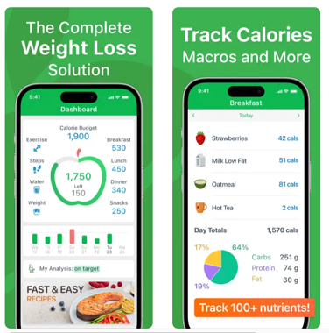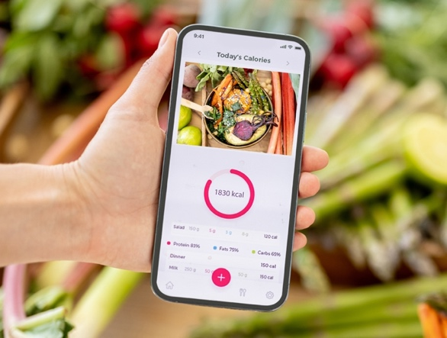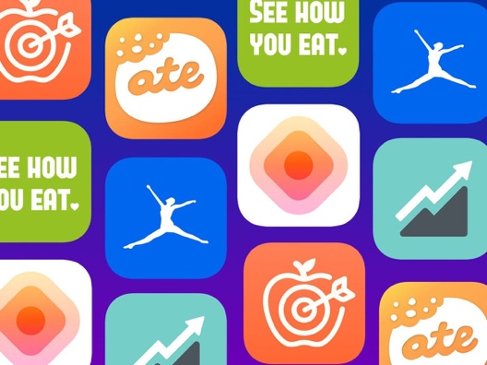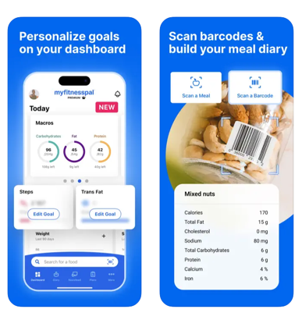
Usability analysis:
- Visibility: Clear features visually remind everyday nutritional targets, including in-progess rings and alerts (red/orange/green).
- Natural mapping: Logging food is strightforward, with intuitive typing and barcode scanner aligned with common user actions.
- Constraints: Hard to take the balance between user’s preference and dietary restrictions. No supervisions on any food intake since mannually operations.
- Error recovery: Easily to edit logged items, and the app provides suggestions of replacements for diet.
- Standardization: Design is consistent, with familiar navigation and data visualizations.
UX analysis:
- Sensual: Visual progress rings with different colors to show the completeness.
- Emotional: Daily encouraging messages will be sent to celebrate for achieving goals.
- Social: Optional to share daily dietary meal plans with others, helping party food preparation.
- Contextual: Users can use this app everywhere, from home to markets, adapting daily needs.
Reference
Random pictures of existing apps online

